Revised
September 2025
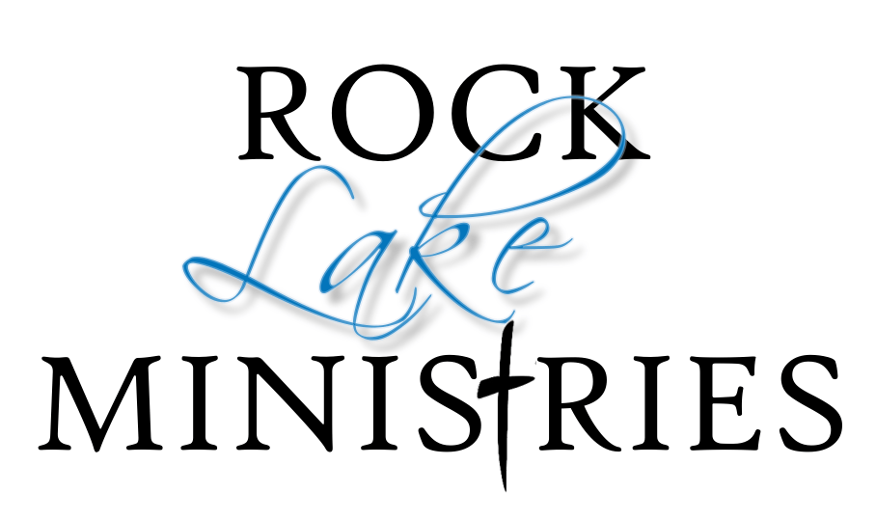
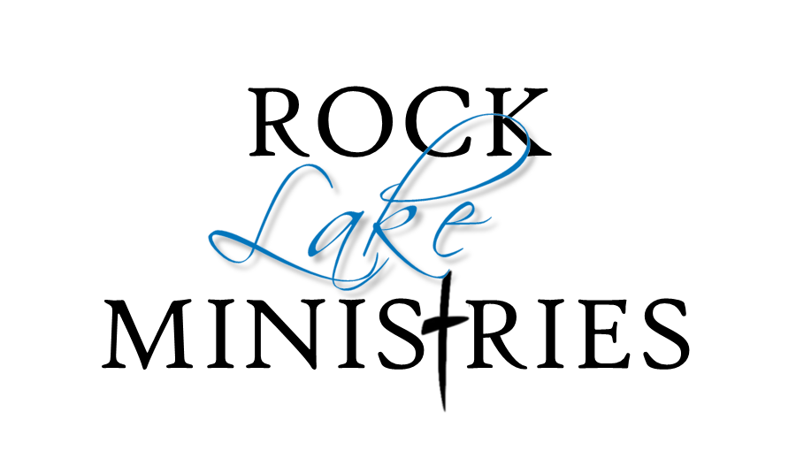

STAFF / RESIDENTS
POLICY & PROCEDURES MANUAL

Goal for Our Community
Our goal for our staff, volunteers and residents (hereby referred to as ‘staff’) is to provide them with a viable mission ministry experience. These ministry opportunities provide a way to serve the Lord allowing for personal spiritual growth and skill development by working within a team environment.

For this end it is necessary that all our staff pursue spiritual maturity. We will have a time of devotions as part of our schedule, but it is expected that our staff will adhere to their own time of personal devotions. “Strength will rise as we wait upon the Lord”. All community members are expected to continue to pursue personal growth.

Code of Conduct
While on RLM owned or operated property, staff agrees to honor and refrain from the following:
- teaching, promoting, or engaging in pre-marital or extra-marital sexual relationships.
- teaching, promoting, or engaging in practices that contradict RLM’s belief, that marriage is only between one naturally born man and one naturally born woman, as it is described in the Holy Bible.
- reading, viewing, or possessing pornographic material
- consumption or possession of alcoholic beverages
- involvement in the occult
- use of profane or blasphemous language.
- littering, destruction of wildlife and/or nature, or hunting
- bringing pets on RLM grounds or in facilities
- wearing immodest clothing or bathing suits including bikinis and speedos
- engaging in any behavior contrary to the Criminal Code of Canada
- While residing at RLM, ALL community members are expected to refrain from tobacco, alcohol, marijuana, pornography and illegal drugs whether on property or off

Supervisory Channels & Communication
All questions/problems are to be directed to your immediate supervisor who, in turn, will forward these to the Director of Operations if deemed necessary. Should any incidences arise, or you just need wisdom, counsel or advice, their door is always open.

Procedures
As a live-in community member, you acknowledge that you reside at RLM for the purpose of engaging with the community. As such, all staff meetings, chapels, services and community events are mandatory. Meeting times and schedules can be received at the front desk and are prepared on a weekly basis.

If you are ill, or unable to attend a required community event, please report this immediately to your respective supervisor.

Work times may vary from day to day, but the expected average is 5-6 hours per day. If you complete your job specific tasks in less time, please report to the front office to see if another department or area needs your assistance. We are a team! If you have a full time job and reside at RLM, you are still expected to participate in work duties. Please see the Director of Operations for expectations.

An 11:00 pm curfew (12:00 am Saturday only) is to be respected. Defined as being in your room, quiet. This is extremely important for both health and morale. Some extenuating circumstances may apply with Director’s discretion.

Staff is asked to let the Director of Operations know prior to leaving camp. It is necessary to ensure RLM is aware of who is on and off property at any given time. If working the following week, please ensure you are well rested for the next event. Monday is our rest day, leftovers will be made available, but kitchen staff are off.

Camp meals (lunch and supper) are provided but should you need snacks outside of mealtimes, these must be provided by yourself. There is no eating/snacking from any of the kitchen fridges or freezers unless approved. If you require fridge space, please check with the Director. Only kitchen staff can be in the kitchen and only the Director or Head cook can approve food outside of mealtimes. Out of honor and respect, we ask that staff (except dishwashers) allow guests priority in the food line.

Male staff are not permitted to be inside female staff quarters and vice versa at any time. Staff is not to pair up romantically with, any students or Rock Lake Ministries guests.

Laundry facilities are located in various locations and may be used by staff when not on duty. DO NOT put sandy towels in, they must be shaken out. Laundry schedules will be provided for personal laundry days. Please note, RLM is not responsible for providing laundry soap for personal laundry unless there is an abundance donated.

Camp equipment such as the quad, riding lawnmowers and golf carts, etc. are only used as directed or by permission of the Director of Operations.

Free Wi-Fi is available on your personal device solely at the discretion of the Director of Operations. As Community members, we ask that you maintain rest and are not over indulging in media or video games while residing at RLM. Remember, we acknowledge that being a part of community means making connection, fellowship and study a priority.

Kitchen staff
All kitchen and dining room staff must adhere to proper hand washing guidelines. Handling food products must be done in adherence to food safety guidelines. Potentially deadly diseases can be spread through improperly handled food. To avoid causing food borne illnesses, always follow safe food handling methods as described by your kitchen leader.

Eating and drinking should only take place in an area designated by leadership and Never in food production/prep areas. After eating or drinking, wash your hands before returning to the kitchen area. Personal leftovers or personal items should never be kept in the main kitchen, walk-in cooler or freezer.

Staff Bringing Children
We ask that you provide adequate childcare for younger children (0-12) while you are working; this is not an RLM responsibility. We are here, however, to help create options and come along side of parents with children. Staff children are expected to attend all programming designed for their age category as available.
Staff children ages 10+ are expected to be a part of the team and complete duties during designated work hours, as appropriate for their age and designated by the Director of Operations.

The following are locations that are off limits to staff children unaccompanied by a parent or without Director’s consent: All non-residential buildings and workspaces.

Care of Accommodations – room standards
As a community member, it is our responsibility to take care of the space that you live in. This includes maintaining our floors (vacuum, sweep, mop), dealing with general clutter, and maintaining reasonable cleanliness of rooms, bathrooms and kitchens. The following are general guidelines; Dirty clothes in basket, clean clothes put away, garbage and recycling not overflowing and no dirty dishes. Room checks may occur from time to time as deemed appropriate by the Director of Operations.

Modesty Dress Code Policy
At camp, we aim to create a respectful, safe for all, and distraction-free environment where everyone feels comfortable and valued. Our dress code reflects our commitment to modesty, safety, and community standards.
1. General Expectations
Clothing should be modest and appropriate for all camp activities.
All attire should promote a positive and respectful atmosphere.
Campers and staff are expected to dress in a way that reflects self-respect and consideration for others.
2. Tops
Shirts must cover the chest/cleavage at all times.
Tank tops should have straps at least two fingers wide; no low-cut or revealing tops. Men should wear shirts at all times unless for beach activities. No sheer or see-through materials unless layered over appropriate clothing.
3. Bottoms
Shorts, skirts, and dresses should be mid-thigh length or longer. No short shorts or mini skirts. Leggings or tight-fitting pants should be worn with a longer top that provides full coverage.
Pants should be worn at the waist and not sag below the hips.
4. Swimwear
Swimwear should be modest and functional. One-piece swimsuits or tankinis that provide full coverage are preferred. Swim trunks should be of appropriate length and fit. No speedos or bikinis will be allowed. A cover-up or shirt must be worn to and from swimming areas.
5. Prohibited Clothing
Clothing with offensive language, images, or symbols. Items that are overly tight, sheer, or revealing. Clothing that promotes violence, drugs, alcohol, or inappropriate behavior.

Good personal hygiene and grooming are expected. Body piercing is permitted at the discretion of the Director of Operations. Visible tattoos are acceptable if they are appropriate. Inappropriate tattoos must be covered up.

For personal safety, footwear should be worn in and around buildings and grounds. If working in the kitchen or dining room all staff is required to wear closed-toed footwear and shirts. Kitchen staff (including dishwashers) must have hair secured either with a clean ball cap or hairnet. If hair is long, it needs to be pulled back or pinned up and secured as above.

According to Deuteronomy 22:5, all biologically male staff must wear men’s clothing and all biologically female staff must wear women’s clothing.

Workplace Harassment
Each person is expected to act in a respectful, courteous, and professional manner at all times and not to engage in or condone harassment. Inappropriate comments or conduct, sexual, racial or similar types of jokes or unwanted sexual advances (touching, staring, assault, teasing, asking for dates, phone calls, comments about a person’s appearance, gossiping, spreading rumors and so on) will not be tolerated within Rock Lake Ministries Inc. or any of its functions. Nor will it be tolerated by its staff off site, via text, phone or on social media.

In the event of a crime
If you see a crime happening, think a crime or fight may happen, see someone being disruptive to guests or staff, or see suspicious activity that could cause harm; if you see an injury or are witness to an accident; go to or send someone to get the Director of Operations immediately. In lieu of them, immediately find a senior staff member or board member of RLM.

DISMISSAL POLICY
Consequences for violating the Code of Conduct, depending on the severity of the behavior, may result in immediate dismissal. The procedure taken for other violations is: first, the behavior will be drawn to your attention. If after three warnings (at the discretion of the Director of Operations) action to correct the behavior has not been satisfactorily taken, dismissal will follow. All violations will be recorded and kept on file.

Who We Are
Rock Lake Ministries is a ministry focused on being a support system for all members of the body of Christ. Our true aim is to support the work that the “Local Church” is already doing. We do this by facilitating teaching and training to produce spiritual maturity. We commit to providing a safe place for leaders, families and individuals to experience God in ways that transform them into His image. (2 Corinthians 3:18, Romans 12:2). We are also committed to meet people where they are at, without judgement, but with encouragement of MORE, as there is always more that we can have of God. Standing with the Church rejoicing and suffering with them. (Romans 12:1-21, 1Corinthians 12:26)

Mission Statement
To provide a safe place where families can be refreshed and restored, through praise and worship and the teaching of God’s Word, so that they can be witnesses for Jesus Christ in their communities and churches.

Rock Lake Ministries
Box 111
Glenora, MB R0K 0Y0
Tel: (204) 825-2842
Tyler@rocklakeministries.com
www.rocklakeministries.com
Tyler Amell, Director of Operations

